Newsletter November 2023

November update - Twinning Project “Further support to the implementation of the National Qualifications Framework” funded by the EU MK IPA 17 SO 01 21

Progress in Component 2: Efforts to Advance the National Qualifications Framework
Approaching the culmination of its implementation with only two months remaining, the Twinning project recently concluded the final mission in a series dedicated to developing qualification standards for various professions. This crucial task significantly contributes to accomplishing the primary objective of Component 2: supporting the further implementation and enhancing the capacities of the National Qualifications Framework (NQF) in alignment with the Quality Assurance (QA) framework.
The sixth mission, falling under Activity 2.2.3, played a pivotal role in finalizing the draft qualification standards for teachers of primary and secondary education, as well as pedagogues. Executed from October 30 to November 3, 2023, Lithuanian experts, Assoc. Prof. Dr. Daiva Lepaitė and Kristina Sutkutė, utilized this timeframe to gather final comments and engage with relevant colleagues. Meetings with representatives from Higher Education Institutions (HEIs), the Bureau for Development of Education, psychologists, pedagogues, teachers from primary and secondary schools, and colleagues from the Ministry of Education and Science (MoES) proved invaluable for refining the draft version of the qualification standards.
Furthermore, the MS experts conducted a field visit, interacting with directors and educational service experts at the primary school "Bratstvo" and the secondary school "Boro Petrushevski" in Skopje. This collaborative effort incorporated recommendations from MS experts and insights from practitioners, ensuring the standards align with new developments and sector requirements. Expectations are high, as these standards are anticipated to serve as a robust foundation for modernizing study programs and providing more attractive options for students. The effort aims to make the education and training system transparent and comprehensible for various users within the country and abroad.
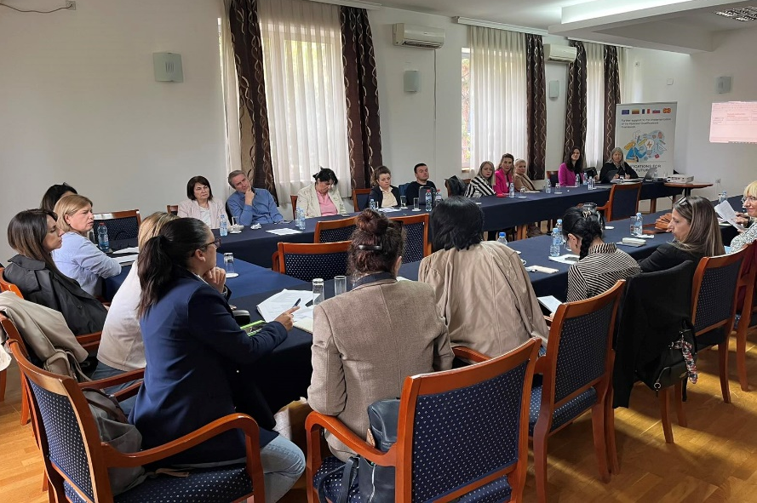
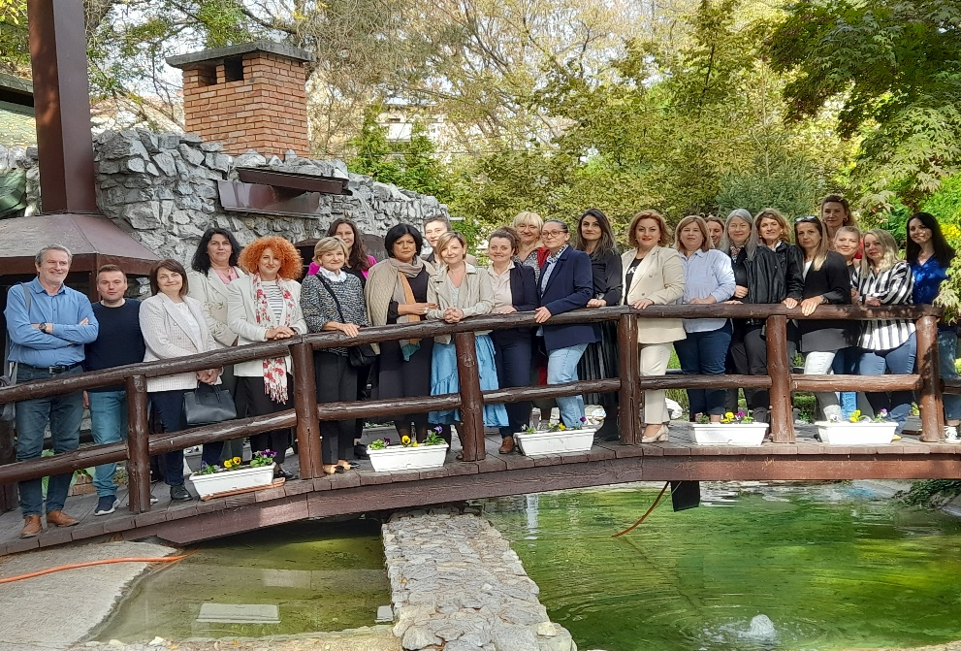

Photos: MS and BC experts finalizing the qualification standards for teachers of primary and secondary education, as well as for pedagogue
Assistance in Updating of the Country’s Referencing Report
The beginning of November was also marked by the completion of another significant activity of the Twinning project. The realization of activity 2.1.4 required a third mission for providing assistance in the drafting of the Referencing report for the country (making a comparison of NQF with the European Qualifications Framework – the EQF in accordance with the new referencing procedures as of 2017). The preparation of the first Referencing report for the country back in 2016 meant a significant step forward in making the education and training system more transparent and understandable for various users in the country and abroad. After seven years and many implemented reforms, it is time for the country to revisit the Referencing report and adhere to the new EQF recommendations. The support of the project in this regard was essential given the complexity of the task.
With their expertise and relevant experiences from the EQF Advisory group, Lithuanian, Slovenian, French and Croatian experts: Almantas Šerpatauskas, Lina Vaitkutė, Odeta Kupetiene, Urška Marentič, Slavica Alojzija Černoša, Brigitte Bouquet and Mile Dzelalija were available for advice and consultations from 6 to 10 November. Engaging in discussions with the established working group for revising the NQF-EQF Referencing report on November 7, 8 and 9, the members of the working group actively participated and outlined the organizational steps that need to be taken in order to perform updating of the referencing report. The mission was also used to explore the implementation of NQF and EQF in North Macedonia, the changes that happened after the 2016 Report, NQF implementation chapter of Cedefop’s European inventory of NQFs, as well as the Roadmap for further development and implementation of the National Qualifications Framework (proposed under activity 2.1.2).
The outputs of all three missions under this activity will serve as a helpful guidance for the working group and will facilitate the process of revising by taking into account the new referencing criteria as of 2017, the criteria and procedures for referencing National Qualifications Frameworks or systems to the European Qualifications Framework, and quality assurance principles for qualifications that are part of the national qualifications.
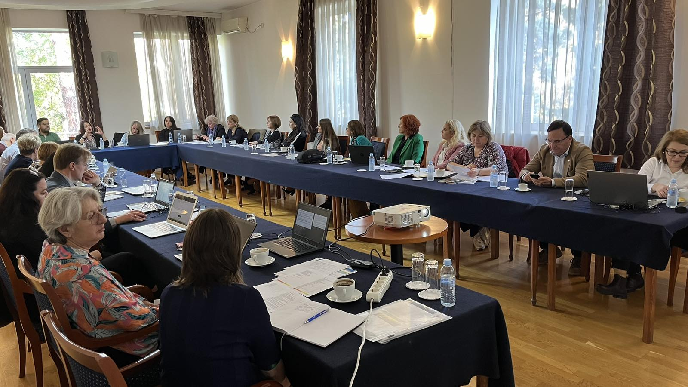

Photos: Meetings held on November 7, 8 and 9 for updating of the Referencing report

Further Development of the QA Framework

Initiated in October, activity 1.1.6 envisaged developing recommendations for quality indicators for the whole NQF. The purpose of the second mission under this activity that took place from 13 to 17 November, was to develop final guidelines and recommendations for evaluation of NQF.
Lithuanian and Croatian experts: Daiva Lepaitė, Kristina Sutkutė, Nora Skaburskienė, and Ana Tecilazić provided recommendations on how to level qualifications based on the NQF level descriptors. In addition, they also opened the floor for discussions on curriculum design and alignment with NQF levels, and presented practical examples from Lithuania. The finalized technical proposals will contribute to the further development of the QA framework.
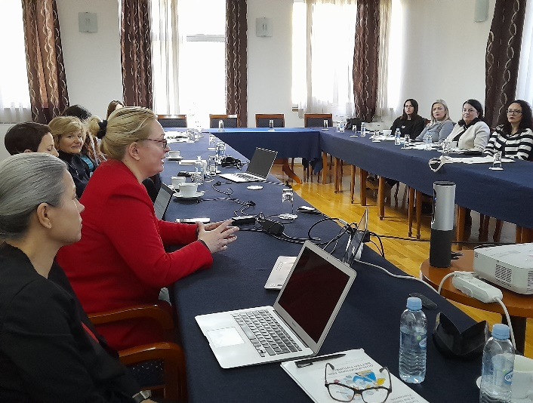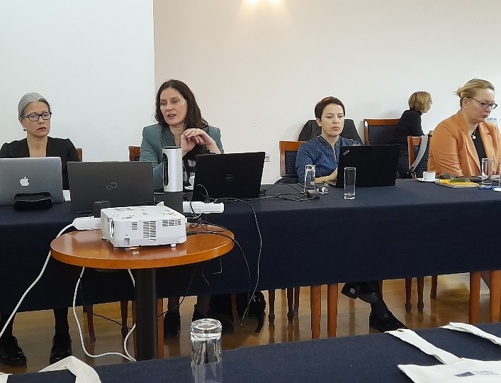
Photos: Working meetings to finalize the technical proposals

This Newsletter was created and maintained with the financial support of the European Union. Its contents are the sole responsibility of the Twinning project and do not necessarily reflect the views of the European Union.

